**HEXADECIMAL TO DECIMAL CONVERSION:**

**EXP NO:27**

**AIM:**To write a C program to implement hexadecimal to decimal conversion.

**APPARATUS:** DEV C++

**ALGORITHM:**

1)      Start from the right-most digit. Its weight (or coefficient) is 1.  
2)      Multiply the weight of the position by its digit. Add the product to the result.  
(0=0, 1=1, 2=2, … 9=9, A=10, B=11, C=12, D=13, E=14,F=15)  
3)      Move one digit to the left. Its weight is 16 times the previous weight.  
4)      Repeat 2 and 3 until you go through all hexadecimal digits.

**PROGRAM:**

#include<stdio.h>  
int main ()  
{  
 int n;  
 printf ("enter the hexadecimal number");  
 scanf("%x”, &n);  
 printf("the decimal value is:%d",n);  
 return 0;  
}

**INPUT:**

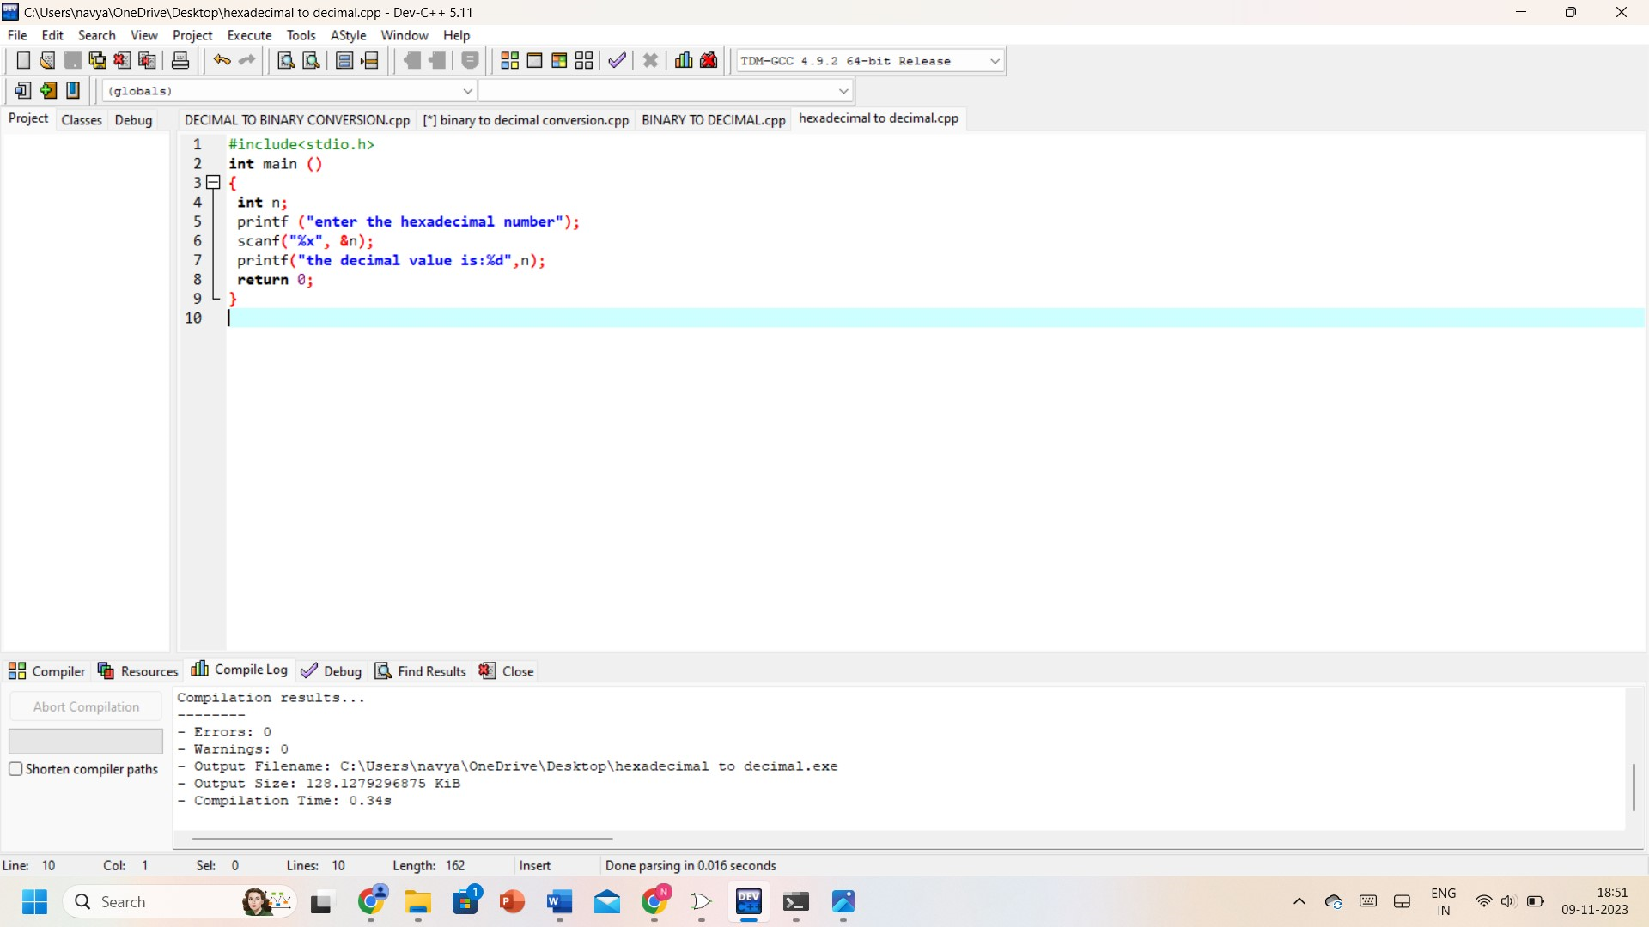

**OUTPUT:**

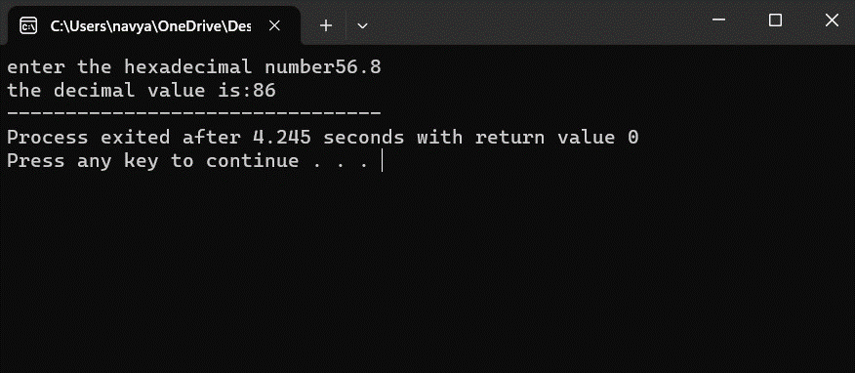

**RESULT:** Thus, the program was executed successfully using DevC++.